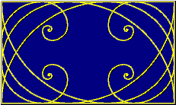

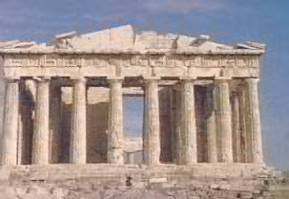Throughout history, this ratio for length to width of rectangles has been considered the most pleasing to the eye. This ratio of longer side to shorter side was named the “golden ratio” by the Greeks. In the world of mathematics, the numeric value is called "phi", named for the Greek sculptor Phidias. Phidias widely used the golden ratio in his works of sculpture. The exterior dimensions of the Parthenon in Athens, built in about 440BC, form a perfect golden rectangle. The space between the columns also form golden rectangles. In fact, there are golden rectangles throughout this structure which is found in Athens, Greece.

# ASSIGNMENT

• Use the quadratic formula to calculate an approximation of the golden ratio (y/x) to the nearest thousandth.(note: x and y are positive)

• Here’s a little advice to help you out:

1. Cross-multiply the given proportion.
2. Move all terms to one side.
3. Solve for y in terms of x (use the quadratic formula).
4. Simplify (try factoring out *x*) until you have it in y = φx form (φ is the *constant* we are looking for!)
5. Since y/x = φ, then…

**The Golden Ratio =**

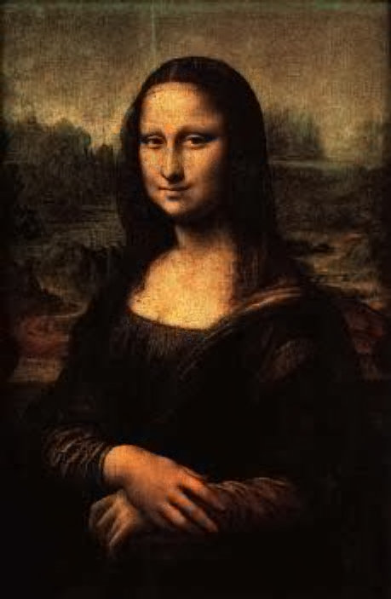Many artists who lived after Phidias have used this proportion. Leonardo DaVinci called it the "divine proportion" and featured it in many of his paintings. To the right is the famous Mona Lisa. Try drawing a rectangle around her face. Are the measurements in a golden proportion? You can further explore this by subdividing the rectangle formed by using her eyes as a horizontal divider. DaVinci did an entire exploration of the human body and the ratios of the lengths of various body parts.

The Golden Mean (or Golden Section), represented by the Greek letter **phi (φ)**, is one of those mysterious natural numbers, like *e* or **pi**, that seem to arise out of the basic structure of our cosmos. Unlike those abstract numbers, however, **phi** appears clearly and regularly in the realm of things that grow and unfold in steps, and that includes *living* things.

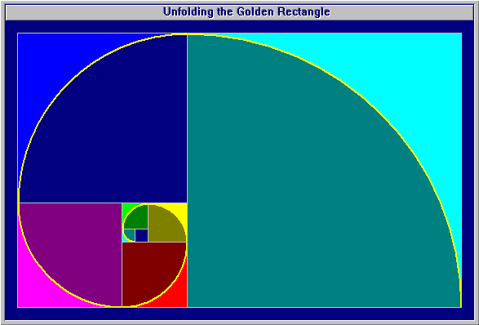The Golden Ratio can occur anywhere. In plain English we can say that two lengths are in the Golden proportion if the ratio of the shorter length to the longer length is equal to the ratio of the longer length to the sum of both lengths. Let S=shorter length and L=longer length. Then using mathematical notation: S/L = L/(S+L).

Text & Pictures used here can be found on the web at:

[www.vashti.net/mceinc/golden.htm](http://www.vashti.net/mceinc/golden.htm)

www.geom.umn.edu/~demo5337/s97b/art.htm

x y x = y .

y x + y

y

x

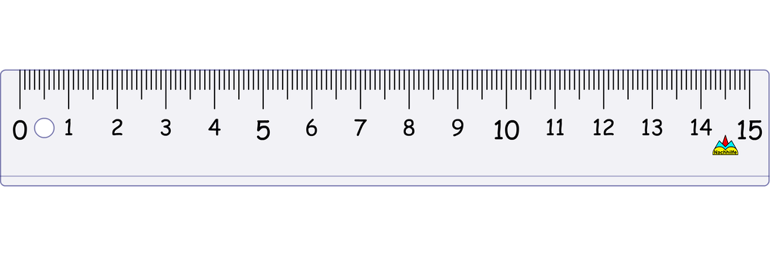

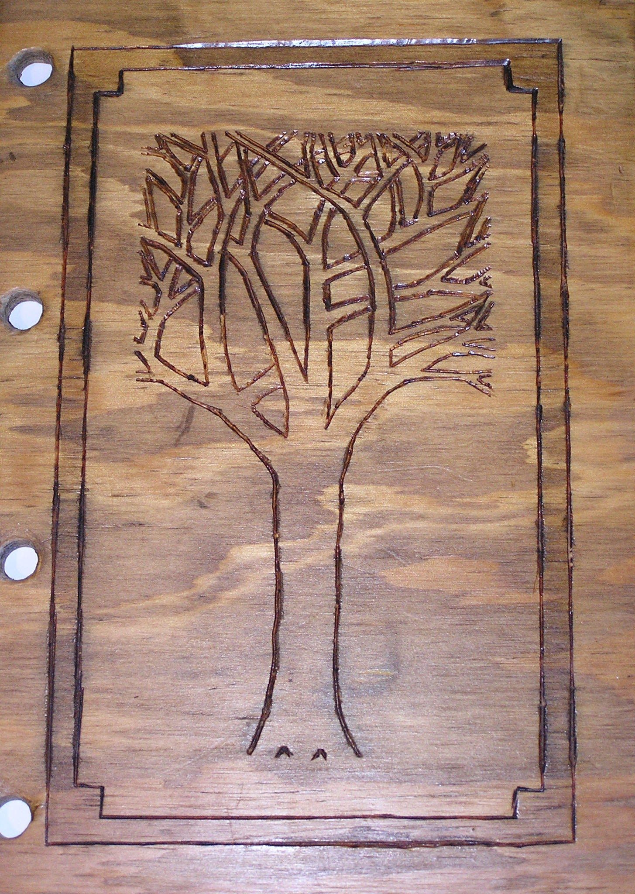

**5 * 1.618 = 8.1**



Use Excel to show the Fibonacci sequence and consecutive ratios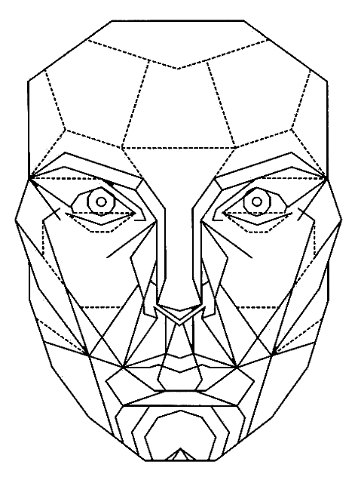

# The Math Behind the Beauty

<http://www.intmath.com/numbers/math-of-beauty.php>

# **The Human Body and the Golden Ratio**

<http://www.goldennumber.net>

John Cleese National Geographic special on beauty

<https://youtu.be/6aVdqeZgv1k(start> at 28:30) and quit at 34)

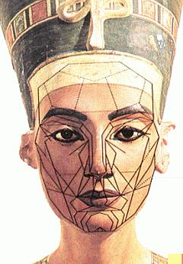

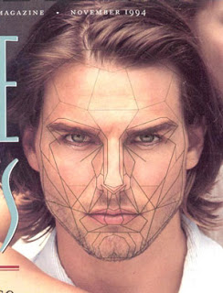

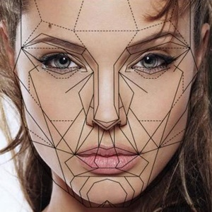

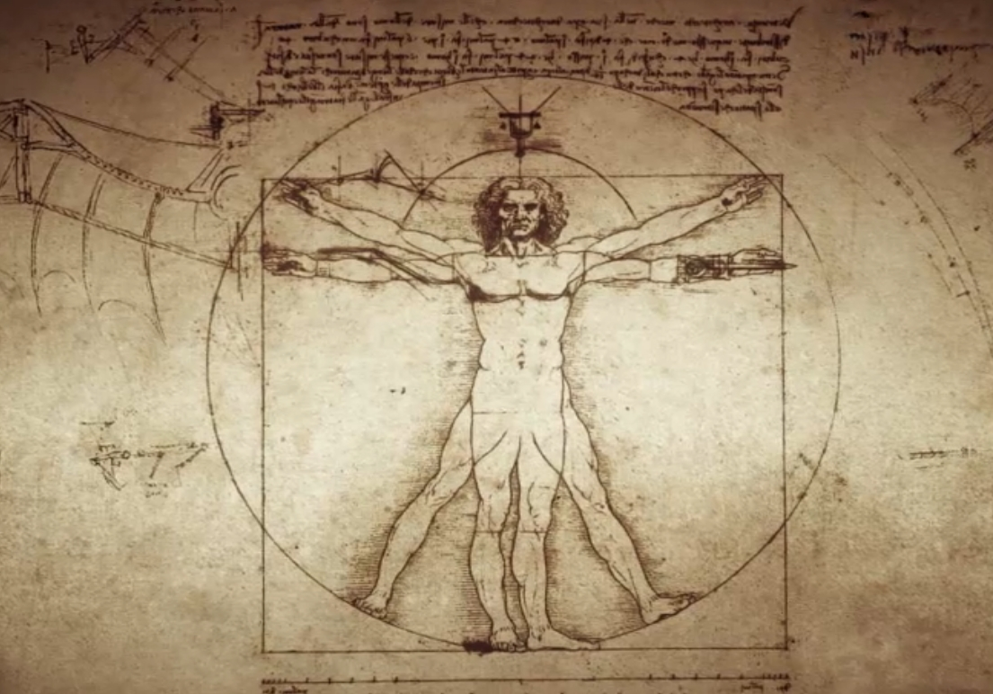

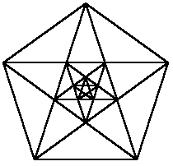

Also use Excel to explore Fibonacci

**Notes from “The Golden Ratio” by Mario Livio**

1. Proof by contradiction of the existence of irrational numbers: Assume √2 is rational. Sqrt2 = p/q where p and q have no common factors (if they did, we’d simply cancel them out leaving us with this very situation). square both sides: 2 = p2/q2 multiply by q2: 2q2=p2  then since 2q2 must be even, p2 must be even, which implies that p itself is even. So we can represent p as 2 times some r or 2r. Hence 2q2 = (2r)2 or 2q2 = 4r2. Dividing by 2, we have q2 = 2r2. By the same logic as before, q2 must be even and therefore q must be even. So p and q are both even. This contradicts our original statement that p and q share no common factors. Therefore our original hypothesis leads us to an absurdity or contradiction, making the original hypothesis false, therefore √2 is not a rational number.

2. Golden properties of the pentagram : each point is a little isosceles triangle with the longer side/ implied base = phi

Also, when inscribed in a pentagon, note that each pentagram contains a smaller pentagon inside, and if we repeat this iteration: a/b, b/c, etc is always golden on to infinity. In words: “every segment is smaller than its predecessor by a factor that is precisely equal to the golden ratio.” * see p. 34 figure 10.

3. Platonic (Regular) Solids: All faces identical and equilateral, Can be inscribed in a sphere

tetrahedron, cube, octahedron, dodecahedron (12), icosahedron (20)

Plato associated these with the 4 “elements” fire, earth, air, and water with dodec. being some mysterious “fifth element” – Aristotle assigned it to the “ether”.

4. Perfect numbers: the number itself is the sum of its lesser factors. 6 = 3 + 2 + 1

Also 28 = 14 + 7 + 4 + 2 + 1 Also 496.

Interesting… 6 day creation, 28 day lunar cycle.

5. Base 10… why? Also base 20: fingers and toes. Also base 12: use thumb to count knuckles. Also Mesopotamian base 60 (remnants – time, angles)? Noboby knows, but 60 is the first # divisible by 1,2,3,4,5,6. Fact: 10 is arbitrary. Could be anything, and perhaps 13 would be better ( much less instances of reducible fractions since 13 is prime). Discuss using the familiar place value system with a different base. Ex. 231 with base 7 would be 2(72)+3(7)+ 1.

Also: Humans can only instantly differentiate without counting, 4 or 5 things. (unlike rain man) Also, connect to barred gate tally. Also to human hand (by 5’s).

6. Spooky: (in degrees) sin 666 + cos (6x6x6) = phi

7. Visual proof of a2+b2=c2 by subtracting 4 congruent abc triangles from a square of length a+b in 2 different arrangements verifies the thm. There are at least 367 different proofs of the PT.

8. Harmonic ratios when playing 2 strings. Dividing a string by consecutive integers creates harmony. ex. 1:1 same note 1:2 sounds good 2:3 sounds good. etc. others are dissonant (harsh).

9. “Most men and women, by birth or nature, lack the means to advance in wealth and power, but all have the ability to advance in knowledge” - Pythagoras

10. a. “O King, for traveling over the country therea re royal roads and roads for common

citizens; but in geometry there is one road for all.” – The reply of Menaechmus, the teacher of Alexander the Great, when Alex asked him for a shortcut to Geometry.

b. “Let no one destitute of Geometry enter my doors.” - The inscription over the entrance to Plato’s Academy.

11. Euclid’s student “But what do I gain from this?” – Euclid told servant to give the boy a coin since he needs to get a physical profit from knowledge.

12. x/1 = (x+1)/x 🡪 x = 1.618… interesting that 1/x = .618… and x2 = 2.618…

✯ also… √(1+√(1+√(1+√(1+√… = 1.618 🡪 proof: let x = the expression, then square both sides to get x2 = 1 + √(1+√(1+√(1+√(1+√… which is x2 = 1 + x the solution of which is 1.618

✯ also… 1 + 1/(1+1/(1+1/(… = 1.618

This sequence made up of all ones converges more slowly than any other irrational making it the “most irrational of the irrational numbers”.

13. The golden rectangle. Take a golden rectangle and cut out a square, this forms a smaller golden rectangle with dimensions .618 of the original, etc. The curiosity is that if you draw two diagonals of any mother-daughter pair they will all intersect at the same point. The series of diminishing rectangles converges to this never-reachable point.

14. During European Dark Ages, the center of Mathematical thought was in … Baghdad

“Al-jabr” from year 825 book by Mohammed ibn-Musa al-Khwarizimi (idea of variable)

Hindu-Arabic number system (place value system) – brought to the west in 1202 by Leonardo of Pisa (Fibonacci) in his book Liber Abaci (book of the abacus) where he advocates this system as far superior then gives examples of problems easily solved by this that would have been incredibly difficult under the roman system. (they used the abacus to do their calculations (a mechanical place value system)

15. Fibonacci Sequence

a. Rabbits: “A certain man put a pair of rabbits in a place surrounded on all sides by a wall. How many pairs of rabbits can be produced from that pair in a year if it is supposed that every month each pair begets a new pair which from the second month on becomes productive?” Progressive pictogram using diff symbols for productive vs. nonproductive pairs.

b. Stairs: “A child is trying to climb a staircase. The max number of steps he can climb at one time is two; that is, he can climb either one step or two steps at a time. If there are n steps in total, in how many different ways, can he climb the staircase? f(1) = 1, f(2) = 2, f(3) = 3, f(4) = 5…8,13,21…

c. The family tree of a drone bee: eggs of worker bees (F) that are not fertilized by a drone (M) become drones (M). Those that are fertilized become either workers or queens (F). Use these simple rules to generate a family tree of M&F’s. Count the number of parents, g-pas, g-g-pas, etc.

* The ratio of two consecutive terms approaches φ.

d. Find the sum of any ten consec Fib. numbers and the answer is always 11 times the sum of the seventh number.

e. The sum of the first n Fib numbers is equal to the (n+2)th Fib number minus 1.

f. George Burns on recursion “How do you live to be 100? There are certain things you have to do, the most important one is to be sure to make it to 99.”

g. Leaf arrangement on a plant (spirals up) usually at an angle of 137.5°. Why special? Check 360/φ = 222.5° and 360 – this = 137.5°. WHY? Most light efficient (leaves will never align exactly so they should avoid shading each other.

Also sunflower counterwinding spirals – ratio of number of spirals in one direction to the other is always a fib/a fib which = φ ex. most common 55/34, also 89/55, also 144/89

WHY? Most space efficient!