Algebra 2 CCP, Mr. Bretsch Lesson: ______________
Chapter 2 - POLYNOMIAL DIVISION & ZEROS of POLYNOMIAL FUNCTIONS

- We already know how to ADD or SUBTRACT polynomials by _____________________________________.
$\left(5x+4\right)+\left(2x-8\right)=$_____________
- We also know how to MULTIPLY polynomials by _______________________________________________.
$\left(x+3\right)\left(2x-1\right)=$______________
- To DIVIDE polynomials, we have two different methods:
- LONG DIVISION (can be used to divide any types of polynomials)
Example: $\frac{x^{3}+5x+2}{x-2}$ * After completing the problem, label the divisor, the dividend, the quotient, and the remainder.

Practice Problem: Divide $\frac{x^{3}-2x^{2}-5x+6}{x-3}$

- SYNTHETIC DIVISION (can only be used for polynomials of the form __________ )
Can I use it to divide by (x-2)? Yes/No (x+4)? Yes/No (2x-5)? Yes/No (x²-3)? Yes/No
Example: $\frac{x^{3}+5x+2}{x-2}$ Practice Problem: $\frac{x^{3}-2x^{2}-5x+6}{x-3}$

- Did you notice anything special about our last example? What does it mean when R = 0? Why is that interesting?

- Use this insight and the results of the last problem to fill in the blanks below.
$x^{3}-2x^{2}-5x+6=\left(x-3\right)\left( \right)( )$

- Now solve the equation: $x^{3}-2x^{2}-5x+6=0$
$x=______$ $x=______$ $x=______$

Whoa. We’ve factored before, but only with quadratics.
We just solved a third degree polynomial equation by factoring. Pretty sweet.
Let’s pause for some vocabulary and concept development here:
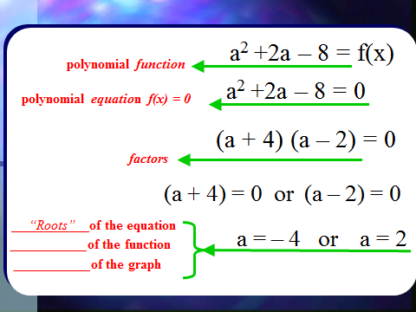
Finding the roots of a polynomial by factoring
a

Constructing a polynomial based on its roots

* Notice the connection between the roots and the factors and that this relationship goes both ways.
If you have a factor, you can find a root and vice-versa!
Example. Use this connection to construct a polynomial with the roots $x=3, -3, and 1$.

Ex. If the x-intercepts of the graph of a quadratic polynomial function are (-2, 0) and (2, 0),
- Find one possible equation for the function with these zeros and show how you obtained it.
f(x) = ______________

- Is this the only quadratic function with these intercepts?
If not, give two others and make a sketch to illustrate.
g(x) = ______________________
h(x) = ______________________

- OK, let’s return to the big idea, which is using factoring to find the zeros of polynomial functions.
Example: Use factoring to find all zeros of $f\left(x\right)=x^{3}+2x^{2}-11x-12$ given that $x=3$ is one of the zeros.
*Hint: Use synthetic division to help you factor out $(x-3).$

*This is all well and good, but you may be thinking it feels kind of phony to be given one of the zeros like that. However, we needed it in order to start the process! We really can only easily factor quadratics. Anything larger than that and we’re generally going to need some place to start, a foothold of sorts.

This is where the… RATIONAL ZERO TEST comes in.
(wait, what does rational mean again? ________________________________________________)

- The Rational Zero Test tells us that every rational zero of a polynomial function must be of the form:
$\frac{p}{q}=\frac{factor of the constant term}{factor of the lead coefficient}$

*Not all of these possibilities are actually zeros, but if there are indeed rational zeros, we can be certain they’re in this list of options.

Example: List all possible rational zeros of the function $g\left(x\right)=2x^{3}-13x^{2}+5x+6$.
* Remember, these factors could be $+ or -$

*Side note: Give examples of zeros that might exist, but couldn’t be found with the rational zero test
(think not rational) x = ______ x = ______ x = ______

- Now that we have a place to look for some possible zeros with which to start the process, let’s tie it all together.
Example: Solve the polynomial equation by factoring using the rational zero test and synthetic division.

$\frac{p}{q}=\frac{ }{ }$ $f\left(x\right)=x^{3}+x^{2}-4x-4$
$0=x^{3}+x^{2}-4x-4$

Check your calculator
to see if these seem reasonable.
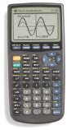
$0=( )( )$
$0=( )( )( )$
$x= x= x=$

- Let’s kick this up a notch! Find all real zeros of the quartic function below.
*Hint: We need to depress this down to a quadratic, so let’s hope the Rat. Zero Test has two winners for us!

Since there are so many options, in the interests of time, we’re going to peek at our calculator to see if any of them seem reasonable.
$\frac{p}{q}=\frac{ }{ }$ $p\left(x\right)=-2x^{4}+13x^{3}-21x^{2}+2x+8$

Extension: Find all zeros of $h\left(x\right)=x^{3}+x$ by factoring (you don’t need synthetic division, but this might feel a little bit “complex”).

